Kasyan Vasyl
Position applied for: Boatswain  Date of birth: 01.03.1962 (age: 55)  Citizenship: Ukraine  Residence permit in Ukraine: No  Country of residence: Ukraine  City of residence: Mariupol  Permanent address: Olimpiska 163-44  Contact Tel. No: +38 (050) 909-69-26 / +38 (062) 940-33-13  E-Mail: 80509096926@mail.ru  U.S. visa: No  E.U. visa: No  Ukrainian biometric international passport: Not specified  Date available from: 01.07.2015  English knowledge: Good  Minimum salary: 2000 $ per month | 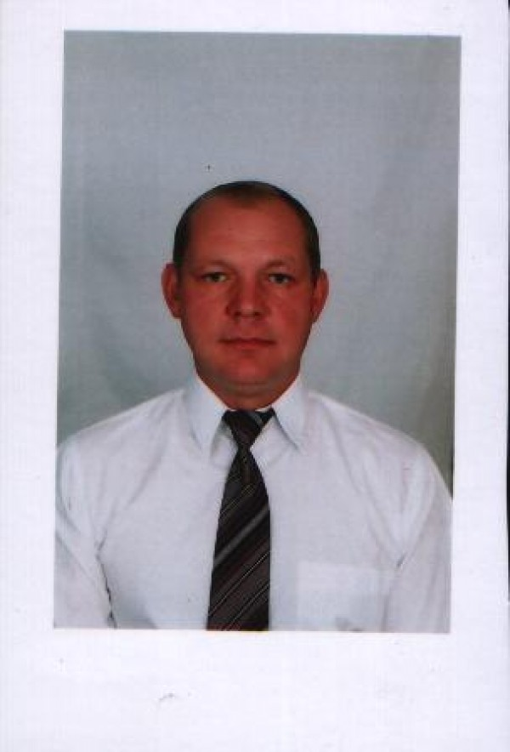

Experience:
Position | From / To | Vessel name | Vessel type | DWT | ME | BHP | Flag | Shipowner | Crewing
Boatswain | 06.08.2013-15.03.2014 | WHISTLER | Bulk Carrier | 38500 |  | - | LIMASSOL | Navarone S.A. | Bark Marine ( Mariupol )
Boatswain | 13.10.2012-09.05.2013 | BUFFLEHEAD | Bulk Carrier | 33000 |  | - | LIMASSOL | Navarone S.A. | Bark Marine ( Mariupol )
Boatswain | 13.03.2011-24.05.2012 | TUNDRA | Bulk Carrier | 31000 |  | - | LIMASSOL | Navarone S.A. | Bark Marine ( Mariupol )
Boatswain | 16.03.2011-20.08.2011 | WIDGEON | Bulk Carrier | 38500 |  | - | LIMASSOL | Navarone S.A. | Bark Marine ( Mariupol )
Boatswain | 08.02.2010-23.03.2010 | TORRENT | Bulk Carrier | 31000 |  | - | LIMASSOL | Navarone S.A. | Bark Marine ( Mariupol )
Boatswain | 01.12.2008-25.05.2009 | Dias | Bulk Carrier | 137000 |  | - | Gong-Cong | A.M. Nomikos- | Bark Agency ( Mariupol )
Boatswain | 06.03.2008-22.06.2008 | Zoitsa | Bulk Carrier | 26990 |  | - |  | Western Shipping | Asimyt West ( Mariupol )
Boatswain | 30.07.2007-21.02.2008 | Umba | Dry Cargo | 7000 |  | - | King Stone | East Line Shiping Ltd | Asimyt West ( Mariupol )
Boatswain | 10.04.2006-07.02.2007 | Imme | Bulk Carrier | 26000 |  | - | Panama | Aptera Maritime | Adriatico ( Mariupol )
Boatswain | 25.03.2005-04.08.2005 | Svyatoy Ioan | Bulk Carrier | 65000 |  | - | Georgia | Starshell Spng Ltd | FAM ( Mariupol )
Boatswain | 14.04.2004-17.12.2004 | Elizaveta | Bulk Carrier | 17000 |  | - | Georgia | Middl Sea Navigation Co Malta | ACMK ( Mariupol )
Able Seaman | 05.09.2002-25.03.2003 | Tampico Bay | Refrigerator | 11000 |  | - | Limassol | Lomar Shiping compani | Diamond Iris Shiping Co Ltd ( Mariupol )

