Krotevych Bogdan Olexandrovych
Position applied for: Ordinary Seaman  Date of birth: 26.03.1993 (age: 24)  Citizenship: Ukraine  Residence permit in Ukraine: No  Country of residence: Ukraine  City of residence: Kyiv  Permanent address: 207fl.,25 Olenivska str.,Kyiv., Ukraine  Contact Tel. No: +38 (050) 931-15-32  E-Mail: bogdankrotevych@yahoo.com  U.S. visa: No  E.U. visa: No  Ukrainian biometric international passport: Not specified  Date available from: 15.05.2013  English knowledge: Good  Minimum salary: 600 $ per month | 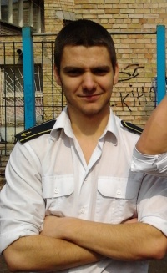

Experience:
Position | From / To | Vessel name | Vessel type | DWT | ME | BHP | Flag | Shipowner | Crewing
Ordinary Seaman | 21.05.2012-21.05.2012 | Delfin | Refrigerator | 193 |  | - | UA | ukrainian danube shipping | &mdash;
Deck Cadet | 10.05.2011-01.08.2011 | Shturman | Ferry | 270 |  | - | UA | KSMA | &mdash;

Documents and further information:
Certificate Basic training and instrustions
Certificate Proficiency in survival craft and rescue boats
Student of Kiev State Maritime Academy
Qualified Seaman Certificate + Endorsement

