Babliak Sergey Nikolaevich
Position applied for: 2nd Officer  Date of birth: 12.12.1967 (age: 49)  Citizenship: Ukraine  Residence permit in Ukraine: No  Country of residence: Ukraine  City of residence: Izmail  Permanent address: Ivana Franko str., 4 apt.21  Contact Tel. No: +38 (048) 415-54-68 / +38 (097) 816-64-48  E-Mail: sergey.babliak@gmail.com  U.S. visa: No  E.U. visa: No  Ukrainian biometric international passport: Not specified  Date available from: 15.01.2014  English knowledge: Good  Minimum salary: 3400 Ð´Ð¾Ð». $ per month | 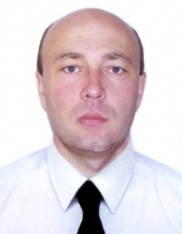

Experience:
Position | From / To | Vessel name | Vessel type | DWT | ME | BHP | Flag | Shipowner | Crewing
2nd Officer | 10.05.2013-10.10.2014 | ST.JOHN GLOGY | Container Ship | 14400 | MAN | 9000 | LIBERIA | COLUMBIA | COLUMBIA
2nd Officer | 15.07.2012-25.12.2012 | NORTERN DELIGHT | Container Ship | 21600 | MAN | 11700 | LIBERIA | NSB | COLUMBIA
2nd Officer | 14.10.2011-10.04.2012 | TIGER SKY | Container Ship | 21600 | MAN | 11700 | LIBERIA | NSB | COLUMBIA
2nd Officer | 02.02.2011-10.08.2011 | TIGER SKY | Container Ship | 21600 | man | 11700 | LIBERIA | NSB | COLUMBIA
2nd Officer | 03.02.2010-11.09.2010 | SIMA PRIDE | Container Ship | 18000 | MAN | 10700 | SINGAPORE | SIMATECH SHIPING | GLORY

