Шацило Алексей Георгиевич
Position applied for: 2nd Engineer  Date of birth: 14.08.1981 (age: 36)  Citizenship: Ukraine  Residence permit in Ukraine: No  Country of residence: Ukraine  City of residence: Odessa  Permanent address: НЕЖИНСКАЯД.40 КВ4  Contact Tel. No: +38 (067) 425-47-91  E-Mail: ira-alexshac@ukr.net  U.S. visa: No  E.U. visa: No  Ukrainian biometric international passport: Not specified  Date available from: 10.08.2009  English knowledge: Moderate  Minimum salary: 1500-2000 $ per month | 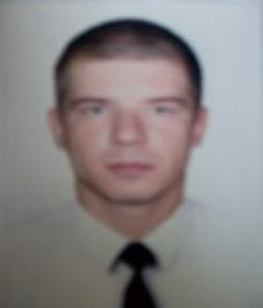

Experience:
Position | From / To | Vessel name | Vessel type | DWT | ME | BHP | Flag | Shipowner | Crewing
Ordinary Seaman | 12.12.2008-09.03.2009 | СТОЛТ-САН | Chemical Tanker |  |  | - | КАЙМАНОВЫЕ ОСТРОВА | СТОЛТ-ТАНКЕРС | АКОМАРИН-ОДЕССА
Ordinary Seaman | 13.03.2008-09.07.2008 | СТОЛТ-СПАН | Chemical Tanker |  |  | - | ЛИБЕРИЯ | СТОЛТ-ТАНКЕРС | АКОМАРИН-ОДЕССА
Ordinary Seaman | 15.09.2007-20.01.2008 | СТОЛТ-СЕРФ | Chemical Tanker |  |  | - | КАЙМАНОВЫЕ ОСТРОВА | СТОЛТ-ТАНКЕРС | АКОМАРИН-ОДЕССА

Documents and further information:
NAME: SHATSILO OLEKSIY GRIGORIEVICH: MARRIED: WIFE IRINA SHATSILO
ADRESS: NEGINSKAYA STR,40/4: MOBILE: 380674254791
LUSTDORFSKAYA ROAD,148/76
NAME OF SCHOOL: OMKTF-ONMA-JUNIOR SPECIALIST 2004-2008
SEAMAN BOOK: AB 409694 06/05/2009-06/05/2014-ILYICHEVSK: NAT.
PASSPORT:KK099963-29/09/1998 -ODESSA
TRAVEL PASSPORT:AM 654043 19/05/2000-19/05/2010-ODESSA: VISA USA
C1/D#87870875:13/09/2007-11/09/2012-LATVIA
LIBERIA SEAMAN BOOK:0824825 24/03/2008-24/03/2013-VIENNA,VIRGINIA USA
LICENCE: NAVIGATOR-00658/2009/08-16/06/2009-16/06/2014-ODESSA
ENDORSEMENT:00658/2009-22/04/2014-ODESSA
GMDSS:GENERAL OPERATOR 00070/2009/03-21/05/2009-21/05/2014-ILYICHEVSK
ENDORSEMENT: 00070/2009/03-21/05/2009-07/05/2014-ILYICHEVSK
BASIC SAFETY:LZ#202300-23/04/2009-23/04/2014-ODESSA
ADV.FIRE FIGHTING:LZ#20311-23/04/2009-23/04/2014-ODESSA
MEDICAL FIRST AID:LZ#12844-23/04/2009-23/04/2014-ODESSA
SURV. CRAFT:LZ#20690-23/04/2009-23/04/2014-ODESSA
CARRIAGE OF DANG.:LZ#13287-23/04/2009-23/04/2014-ODESSA
OIL TANKER SPECIALIZED:LZ#01530-27/04/2009-27/04/2014-ODESSA
CHEMICAL TANKER SPECIALIZED:LZ#02265-27/04/2009-27/04/2014-ODESSA
RADAR-ARPA:LZ#02050-22/04/2009-22/04/2014-ODESSA
TANKER FAMILIAR.:LZ#20148-23/04/2009-23/04/2014-ODESSA
MEDICAL EXAM.:09/12/2008-09/12/2009-ODESSA
YELLOW FEVER:13/05/2004-13/04/2014-ODESSA

