Sydorenko Igor
Position applied for: 3rd Officer  Date of birth: 30.08.1990 (age: 27)  Citizenship: Ukraine  Residence permit in Ukraine: No  Country of residence: Ukraine  City of residence: Mariupol  Contact Tel. No: +38 (062) 941-56-83 / +38 (097) 801-49-53  E-Mail: yana-na2009@mail.ru  Skype: i_g_o_r11  U.S. visa: No  E.U. visa: No  Ukrainian biometric international passport: Not specified  Date available from: 31.08.2017  English knowledge: Moderate  Minimum salary: 2200 $ per month | 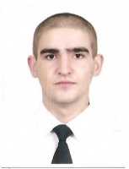

Experience:
Position | From / To | Vessel name | Vessel type | DWT | ME | BHP | Flag | Shipowner | Crewing
Able Seaman | 26.05.2013-17.12.2013 | Zografia 1 | Bulk Carrier | 40000 |  | - | Panama |  | Adriatico

