Покровский Вячеслав Германович
Position applied for: Master  Date of birth: 23.01.1952 (age: 65)  Citizenship: Russia  Residence permit in Ukraine: No  Country of residence: Russia  City of residence: Vladivostok  Permanent address: Тухачевского 70 к.2  Contact Tel. No: +7 (423) 250-30-34  E-Mail: skipper.prim@mail.ru  U.S. visa: No  E.U. visa: No  Ukrainian biometric international passport: Not specified  Date available from: 20.12.2009  English knowledge: Good  Minimum salary: 6000 $ per month | 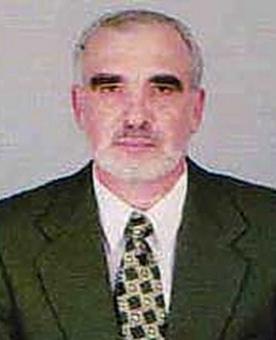

Experience:
Position | From / To | Vessel name | Vessel type | DWT | ME | BHP | Flag | Shipowner | Crewing
Master | 29.05.2009-29.09.2009 | DD Vanguard | Bulk Carrier | 26518 | MAN B&W | 8820 | Panama | Foolproof Navigation S.A., Panama | DMZ Crewing
Master | 15.07.2008-15.02.2009 | DD Leader | Bulk Carrier | 25759 | Misubishi | 6000 | SVAG | Catalina Overseas Ltd | DMZ Crewing
Master | 03.09.2007-21.02.2008 | Agzu | Dry Cargo | 5485 | Russian Diesel | 2x1500 | R.F. | Ardis | Ardis-Crewing
Master | 19.07.2006-02.03.2007 | Uranus L | Dry Cargo | 9865 | MAK | 6000 | Comoros | Norfes-Marine-Service | Norfes-Marine-Service
Master | 22.12.2005-18.05.2006 | Samarga | Dry Cargo | 5500 | Russian Diesel | 2x1500 | R.F. | Ardis | Ardis-Crewing
Master | 16.04.2005-01.12.2005 | Uranus L | Dry Cargo | 9865 | MAK | 6000 | Comoros | Norfes-Marine-Service | Norfes-Marine-Service
Master | 17.02.2005-25.03.2005 | Geroy | Dry Cargo | 5561 | Sulzer | 6000 | R.F. | Norfes-Marine-Service | Norfes-Marine-Service
Master | 16.10.2004-24.01.2005 | Agzu | Dry Cargo | 5485 | Russian Diesel | 2x1500 | R.F. | Ardis | Ardis-Crewing
Master | 15.03.2003-30.06.2003 | Sea Breath | Dry Cargo | 2900 | Sulzer | 1560 | Cambodia | Trek-balu | Trek-Balu
Master | 20.03.2001-14.02.2003 | Pioner Slavyanki | General Cargo | 6046 | MAN B&W | 6100 | Россия | Fesco | Trek-Balu

Documents and further information:
All Certificates are vilid till 25th of March 2012.

