Kovalov Denis
Position applied for: Motorman 2nd class  Date of birth: 05.08.1981 (age: 36)  Citizenship: Ukraine  Residence permit in Ukraine: Yes  Country of residence: Ukraine  City of residence: Mariupol  Contact Tel. No: +38 (096) 302-41-07  E-Mail: 2341kuznec@gmail.com  Skype: Denis Kovalov  U.S. visa: No  E.U. visa: No  Ukrainian biometric international passport: Not specified  Date available from: 30.09.2017  English knowledge: Moderate  Minimum salary: 600 $ per month | 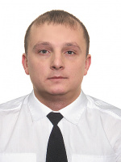

Experience:
Position | From / To | Vessel name | Vessel type | DWT | ME | BHP | Flag | Shipowner | Crewing
Motorman 2nd class | 02.03.2017-05.05.2017 | Petro Halaktionov | Tug Boat | 884 | G70 | - | Ukraine | Ship Repair Factory | Ship Repair Factory

