Yudin Denys Glebovich
Position applied for: 3rd Officer  Date of birth: 10.10.1980 (age: 37)  Citizenship: Ukraine  Residence permit in Ukraine: No  Country of residence: Ukraine  City of residence: Kiliya  Permanent address: Tatarbunarskaya 4/7  Contact Tel. No: +38 (048) 434-27-12 / +38 (067) 293-13-25  E-Mail: denys.yudin@gmail.com  U.S. visa: No  E.U. visa: No  Ukrainian biometric international passport: Not specified  Date available from: 28.06.2012  English knowledge: Good  Minimum salary: 3000 $ per month | 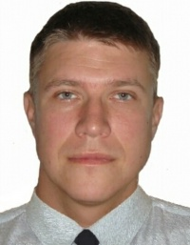

Experience:
Position | From / To | Vessel name | Vessel type | DWT | ME | BHP | Flag | Shipowner | Crewing
3rd Officer | 02.02.2012-05.06.2012 | Seattle Reefer | Container Ship | 8400 |  | - | Liberia |  | Germea Maritime
Able Seaman | 13.05.2011-25.10.2011 | Cape Manuel | Container Ship | 37000 |  | - | Cyprus | King Albert | Columbia
Able Seaman | 22.02.2010-22.08.2010 | CMA CGM Cortes | Container Ship | 27000 |  | - | Marshal Islands | Alpha Ship | UMS
Able Seaman | 01.10.2010-09.01.2010 | Pollux | Container Ship | 13000 |  | - | Marshal Islands | Alpha Ship | UMS
Able Seaman | 18.06.2009-30.10.2009 | Spica | Container Ship | 11100 |  | - | Marshal Islands | Alpha Ship | UMS

Documents and further information:
I am looking for a job as 3 rd. Ready Ã¢â¬â 28.06.2012. All Documents according STCW.
My level of English is good. Have experience on General cargo, Container.
Working in rank of 3/OFF

