Matvieiev Maksym
Position applied for: Ordinary Seaman  Date of birth: 03.09.1989 (age: 28)  Citizenship: Ukraine  Residence permit in Ukraine: Yes  Country of residence: Ukraine  City of residence: Mariupol  Contact Tel. No: +38 (096) 038-87-77  E-Mail: zveruga8977@ukr.net  Skype: policemens  U.S. visa: No  E.U. visa: No  Ukrainian biometric international passport: Not specified  Date available from: 25.11.2016  English knowledge: Poor  Minimum salary: 700 $ per month | 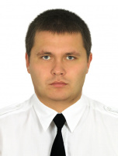

Experience:
Position | From / To | Vessel name | Vessel type | DWT | ME | BHP | Flag | Shipowner | Crewing
Able Seaman | 10.09.2015-07.06.2016 | Lena | General Cargo | 7000 |  | - | Malta |  | &mdash;

