Zakharov Vitaliy Vicktorovich
Position applied for: Deck Cadet  Date of birth: 21.03.1993 (age: 24)  Citizenship: Ukraine  Residence permit in Ukraine: No  Country of residence: Ukraine  City of residence: Mariupol  Permanent address: Mitropolitskaya st 18  Contact Tel. No: +38 (050) 164-01-33 / +38 (097) 923-92-58  E-Mail: zaharovvitaliyvicktorovich_2010@mail.ru  U.S. visa: No  E.U. visa: No  Ukrainian biometric international passport: Not specified  Date available from: 10.05.1993  English knowledge: Good  Minimum salary: 300 $ per month | 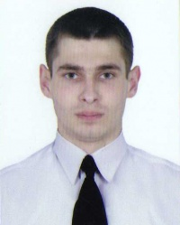

Experience:
Position | From / To | Vessel name | Vessel type | DWT | ME | BHP | Flag | Shipowner | Crewing
Deck Cadet | 01.06.2010-30.07.2010 | Николай Иванченко | Tug Boat | 198 р. т. | 2х441 кВт | I-010336 | Украина | Мариупольский морской порт | &mdash;

Documents and further information:
Все документы готовы, знание английского языка, готов приступить к работе.

