Brashchenko Andrey Anatolievich
Position applied for: 3rd Engineer  Date of birth: 25.05.1972 (age: 45)  Citizenship: Ukraine  Residence permit in Ukraine: Yes  Country of residence: Ukraine  City of residence: Kramatorsk  Permanent address: Drujkovskaya 10  Contact Tel. No: +38 (095) 396-28-46  E-Mail: boks_72@mail.ru  U.S. visa: No  E.U. visa: No  Ukrainian biometric international passport: Not specified  Date available from: 30.08.2016  English knowledge: Moderate  Minimum salary: 4700 $ per month | 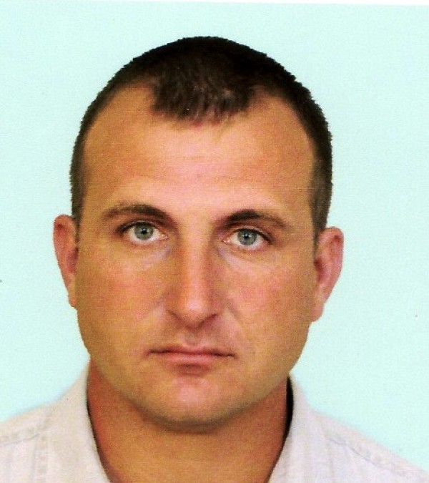

General details:
Document | Number | Place of issue | Date of expiry
Civil passport | BA 781870 | - | 00.00.0000
Seamanâs passport | AB 488813 | Ukraine | 01.06.2017
Tourist passport | PO 268558 | Ukraine | 30.07.2018

Certificates:
Type | Number | Place of issue | Date of expiry
(III/2) 2nd Engineer> | 11351/2016/11 | Ukraine | 00.00.0000
Endorsment | 11351/2016/11 | Ukraine | 19.04.2021
Basic Safety Course (VI/1) |  | Ukraine | 04.04.2021
Security related training (VI/6) |  | Ukraine | 26.02.2019
Advanced Fire Fighting (VI/3) |  | Ukraine | 22.04.2021
Medical First Aid (VI/4) |  | Ukraine | 04.04.2021
Survival Craft and Rescue Boats (VI/2-1) |  | Ukraine | 22.04.2021
Tankermen Familiarization (all tankers) |  | Ukraine | 26.04.2018
Tankermen Familiarization (oil only) |  | Ukraine | 19.05.2021
Tankermen Familiarization (chemical only) |  | Ukraine | 19.05.2021
Tankermen CHEMICAL specialized course |  | Ukraine | 05.07.2018
Ship Security Officer (VI/5) |  | Ukraine | 04.04.2021
HAZMAT (B-V/c) |  | Ukraine | 04.04.2021
Yellow Fever Vaccination |  | Ukraine | 25.11.2024
Medical Fitness Certificate |  | Ukraine | 14.09.2016

Experience:
Position | From / To | Vessel name | Vessel type | DWT | ME | BHP | Flag | Shipowner | Crewing
3rd Engineer | 10.10.2015-19.03.2016 | Gulf Huwaylat | Oil Chemical Tanker | 45967 | Hyundai B&W 6S50MC-C | 12900 | Saudi Arabia | Gulf Huwaylat corp. | Acomarin
4th Engineer | 25.01.2015-08.06.2015 | Gulf Huwaylat | Oil Chemical Tanker | 45967 | Hyundai B&W 6S50MC-C | 12900 | Saudi Arabia | Gulf Huwaylat corp. | Acomarin
4th Engineer | 06.04.2014-10.08.2014 | Gulf Huwaylat | Oil Chemical Tanker | 45967 | Hyundai B&W 6S50MC-C | 12900 | Saudi Arabia | Gulf Huwaylat corp. | Acomarin
4th Engineer | 27.07.2013-17.12.2013 | Gulf Huwaylat | Oil Chemical Tanker | 45967 | Hyundai B&W 6S50MC-C | 12900 | Saudi Arabia | Gulf Huwaylat corp. | Acomarin
Engine Fitter | 15.10.2012-18.04.2013 | Gulf Fanatir | Oil Chemical Tanker | 45920 | Hyundai B&W 6S50MC-C | 12900 | Saudi Arabia | Gulf Fanatir corp. | Acomarin
Engine Fitter | 29.09.2011-03.04.2012 | Gulf Fantir | Oil Chemical Tanker | 45920 | Hyundai B&W 6S50MC-C | 12900 | Saudi Arabia | Gulf Fanatir corp. | Acomarin
Engine Fitter | 10.02.2011-07.08.2011 | Gulf Huwaylat | Oil Chemical Tanker | 45967 | Hyundai B&W 6S50MC-C | 12900 | Saudi Arabia | Gulf huwailat corp. | Acomarin
Engine Fitter | 29.04.2010-13.10.2010 | Gulf Fanatir | Oil Chemical Tanker | 45920 | Hyundai B&W 6S50MC-C | 12900 | Saudi Arabia | Gulf Fanatir corp. | Acomarin
Engine Fitter | 26.10.2009-27.01.2010 | Stolt Helluland | Chemical Tanker | 49 000 | B&W | 12480 | Liberia | Nor | Acomarin
Fitter | 22.11.2008-19.03.2009 | Hawrim | Gas Tanker | 26207 | B&W | 16800 | Norway | BW GAS AS | Acomarin
Fitter | 25.08.2008-29.09.2008 | EX Helderberg | Container Ship | 52615 | Sulzer | 2x26800 | Liberia | Danaos | Danaos
Fitter | 14.09.2007-28.02.2008 | Guildo | Chemical Tanker | 7087 | MAK | 3840 | Italy | Socatra | SP Management
Fitter | 18.05.2007-20.08.2007 | Ermoupolis | Bulk Carrier | 26795 | Sulzer | 11500 | Panama | Sealink Marine inc | Esmeralda
Fitter | 04.03.2006-11.02.2007 | Gulf Dove | Chemical Tanker | 14037 | Mitsubishi B&W | 6000 | Panama | Emirates Treading Agency | Esmeralda
Fitter | 19.03.2005-29.12.2005 | Royoman | Bitumen Tanker | 7284 | B&W | 5000 | Panama | Emirates Treading Agency | Esmeralda

