Козопас С.С.
Position applied for: Able Seaman  Date of birth: 13.03.1974 (age: 43)  Citizenship: Ukraine  Residence permit in Ukraine: No  Country of residence: Ukraine  City of residence: Beryslav  Permanent address: г.Берислав Херсонской обл.  Contact Tel. No: +38 (066) 257-33-75  E-Mail: stepaok@meta.ua  U.S. visa: No  E.U. visa: No  Ukrainian biometric international passport: Not specified  Date available from: 10.08.2009  English knowledge: Moderate  Minimum salary: 1200 $ per month | 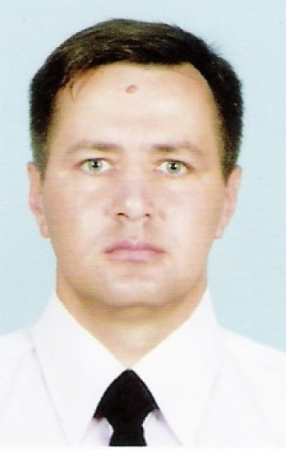

Experience:
Position | From / To | Vessel name | Vessel type | DWT | ME | BHP | Flag | Shipowner | Crewing
Motorman 1st class | 13.08.2008-12.06.2009 | Svyatoy Pavel | Bulk Carrier | 19452 |  | - | Panama | Medpad Maritime Limited | Масив (г.Мариуполь)
Ordinary Seaman | 26.11.2007-06.06.2008 | Svyatoy Pyotr | General Cargo | 11854 |  | - | Panama | Karabil Shipping Limited | Мфсив (г.Мариуполь)

