Cherniavskyi Volodymyr
Position applied for: 2nd Officer  Date of birth: 14.04.1982 (age: 35)  Citizenship: Ukraine  Residence permit in Ukraine: No  Country of residence: Ukraine  City of residence: Kyiv  Contact Tel. No: +38 (068) 430-22-72  E-Mail: fleet_82@mail.ru  U.S. visa: No  E.U. visa: No  Ukrainian biometric international passport: Not specified  Date available from: 20.12.2013  English knowledge: Good  Minimum salary: 1 $ per month | 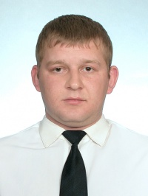

Experience:
Position | From / To | Vessel name | Vessel type | DWT | ME | BHP | Flag | Shipowner | Crewing
2nd Officer | 22.06.2013-17.09.2013 | Desoto Tide | PSV â Platform Supply/Support Vessel | 2308 | Cummins a SK 60 | 7342 | Vanuatu | TDW | TDW
2nd Officer | 05.06.2013-22.06.2013 | Ward Tide | Anchor Handling Tug Supply | 1674 | Caterpillar 2x2575 | 2x2575 | Vanuatu | TDW | TDW
2nd Officer | 26.11.2012-06.03.2013 | Melton Tide | PSV â Platform Supply/Support Vessel | 3100 | 2xWartsila 9L26A | 2x3741 | Vanuatu | TDW | TDW

