Chernenko Aleksandr Aleksandrovich
Position applied for: Junior Officer  Date of birth: 21.02.1987 (age: 30)  Citizenship: Ukraine  Residence permit in Ukraine: No  Country of residence: Ukraine  City of residence: Bilhorod-Dnistrovskyy  Permanent address: Komsomolskaya str.,6  Contact Tel. No: +38 (067) 952-17-74 / +38 (098) 086-22-19  E-Mail: regionman@rambler.ru  U.S. visa: No  E.U. visa: No  Ukrainian biometric international passport: Not specified  Date available from: 01.12.2011  English knowledge: Good  Minimum salary: 2800 $ per month | 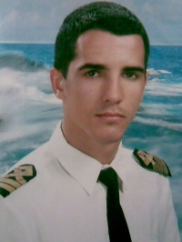

Experience:
Position | From / To | Vessel name | Vessel type | DWT | ME | BHP | Flag | Shipowner | Crewing
Ordinary Seaman | 26.04.2013-29.11.2013 | Mare Caribbean | Crude Oil Tanker | 38100 |  | - | Marshal il-s,Majuro | CSM | CSM
Able Seaman | 17.03.2010-25.02.2011 | Slavutich-16 | Tug Boat |  |  | - | Ukraine |  | Professional
Ordinary Seaman | 19.03.2009-20.10.2009 | Chemtrans Sun | Shuttle Tanker |  |  | - | Liberiya |  | BSM Cyprus
Ordinary Seaman | 16.07.2008-01.02.2009 | YM Yantian | Container Ship |  |  | - | Cyprus |  | Danaos
Deck Cadet | 18.08.2006-17.01.2007 | CMA CGM Comodo | Container Ship |  |  | - | Greek |  | Danaos
Ordinary Seaman | 28.04.2005-05.05.2006 | Jupiter |  |  |  | - | Ukraine | Capitan | Antarktika

