Shcherbakov Yuriy
Position applied for: 2nd Officer  Date of birth: 19.01.1988 (age: 29)  Citizenship: Ukraine  Residence permit in Ukraine: No  Country of residence: Ukraine  City of residence: Odessa  Permanent address: Glushko 15  Contact Tel. No: +38 (093) 951-71-60  E-Mail: yurello@bigmir.net  U.S. visa: No  E.U. visa: No  Ukrainian biometric international passport: Not specified  Date available from: 24.01.2014  English knowledge: Good  Minimum salary: 4500 $ per month | 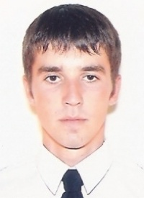

Experience:
Position | From / To | Vessel name | Vessel type | DWT | ME | BHP | Flag | Shipowner | Crewing
2nd Officer | 27.01.2013-13.06.2013 | CSL Metis | Bulk Carrier |  |  | - | Bahamas | CSL | V.Ships
2nd Officer | 00.00.0000-00.00.0000 | Nelvana |  |  |  | - |  |  | &mdash;

Documents and further information:
Good day,Im looking jobs and ready for joining.Have USA Visa, Chief Officer CoC, DP Induction (NI), BOSIET (OPITO).Marlins test 87Have good experience on self-unloader bulk carriers.Best regards.Yuriy

