Izmayilshchuk Oleksandr
Position applied for: Able Seaman  Date of birth: 03.03.1988 (age: 29)  Citizenship: Ukraine  Residence permit in Ukraine: No  Country of residence: Ukraine  City of residence: Izmail  Permanent address: Железнякова 242  Contact Tel. No: +38 (048) 417-95-20 / +38 (093) 814-09-30  E-Mail: gaillard-galopin@mail.ru  U.S. visa: No  E.U. visa: No  Ukrainian biometric international passport: Not specified  Date available from: 01.07.2012  English knowledge: Good  Minimum salary: 900 $ per month | 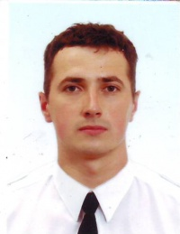

Experience:
Position | From / To | Vessel name | Vessel type | DWT | ME | BHP | Flag | Shipowner | Crewing
Ordinary Seaman | 06.01.2012-15.06.2012 | Giannis | Dry Cargo | 42000 |  | 7944 | Malta | Oak Shipping LTD,Valletta | Marine Pro Service
Ordinary Seaman | 11.07.2010-16.03.2011 | Calypso N | Dry Cargo | 32000 |  | 7723 | Limassol | Leopard Shipping Co.Ltd | Marine Pro Service
Ordinary Seaman | 30.08.2009-20.02.2010 | MSC Pioneer | Container Ship | 22000 | sultzer | 17400 | Gibraltar | Target Marine | Marine Pro Service
Ordinary Seaman | 15.09.2008-08.05.2009 | msc Pioneer | Container Ship | 22000 | sultzer | 17400 | Gibraltar | Target Marine | Marine Pro Service

