Евгений Корольов
Position applied for: Electrician  Date of birth: 18.01.1989 (age: 28)  Citizenship: Ukraine  Residence permit in Ukraine: No  Country of residence: Ukraine  City of residence: Sevastopol  Permanent address: 33 Pogorelova str.  Contact Tel. No: +38 (066) 686-06-35  E-Mail: jonik1989@yandex.ru  U.S. visa: No  E.U. visa: No  Ukrainian biometric international passport: Not specified  Date available from: 13.05.2009  English knowledge: Good  Minimum salary: 600 $ per month | 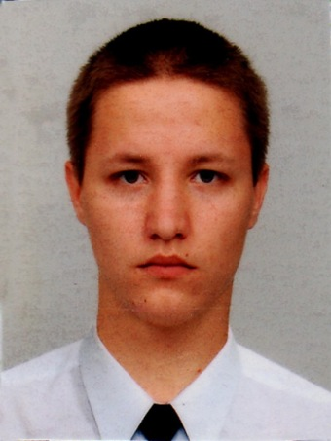

Experience:
Position | From / To | Vessel name | Vessel type | DWT | ME | BHP | Flag | Shipowner | Crewing
Electrician | 13.10.2008-13.12.2008 | Indiga | Shuttle Tanker | 1542 |  | - | Rus | M/p 60233 | &mdash;

