Kononenko Oleg Igorevych
Position applied for: Electrician  Date of birth: 14.12.1979 (age: 37)  Citizenship: Ukraine  Residence permit in Ukraine: No  Country of residence: Ukraine  City of residence: Mariupol  Permanent address: Pashkovskogo str.35 fl.3  Contact Tel. No: +38 (062) 957-65-13 / +38 (067) 316-67-97  E-Mail: oleg.7914@mail.ru  U.S. visa: No  E.U. visa: No  Ukrainian biometric international passport: Not specified  Date available from: 19.02.2014  English knowledge: Poor  Minimum salary: 1200 $ per month | 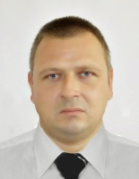

Experience:
Position | From / To | Vessel name | Vessel type | DWT | ME | BHP | Flag | Shipowner | Crewing
Electrician | 06.03.2013-02.02.2014 | m/v"Krymskaya" | Suction Dredger | 1090 r.t. | 6NVD A3 | 2*620kWt | Ukraine | JPM Shp.co | &mdash;

