Ilyenko Grigoriy
Position applied for: Chief Engineer  Date of birth: 02.01.1955 (age: 62)  Citizenship: Ukraine  Residence permit in Ukraine: Yes  Country of residence: Ukraine  City of residence: Zaporizhia  Permanent address: 7 Kirova Str.  Contact Tel. No: +38 (050) 162-80-54 / +38 (061) 224-41-25  E-Mail: il_grigory@meta.ua  Skype: grigory413  U.S. visa: No  E.U. visa: No  Ukrainian biometric international passport: Not specified  Date available from: 25.07.2017  English knowledge: Good  Minimum salary: 8000 $ per month | 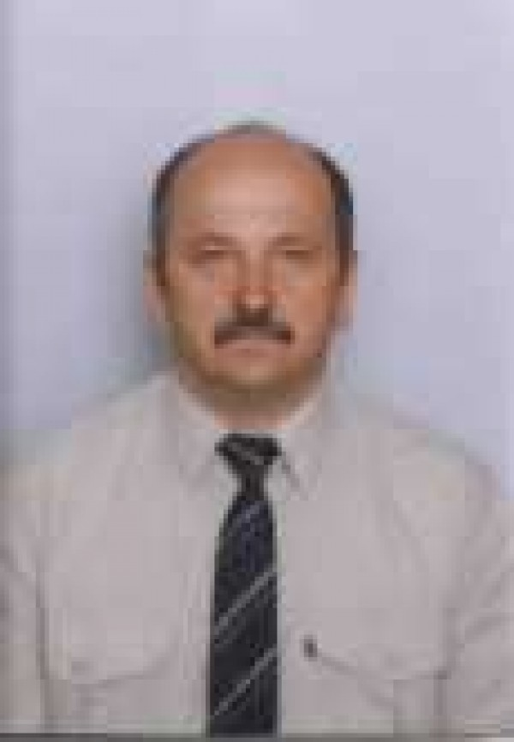

General details:
Document | Number | Place of issue | Date of expiry
Civil passport | CB 023059 | Ukraine | 00.00.0000
Seamanâs passport | AB 514946 | Kherson | 16.07.2018
Tourist passport | EK278922 | UKRAINE | 22.06.2018

Certificates:
Type | Number | Place of issue | Date of expiry
First-class engineer | 10852/2016/11 | Kherson | 00.00.0000

Experience:
Position | From / To | Vessel name | Vessel type | DWT | ME | BHP | Flag | Shipowner | Crewing
Chief Engineer | 09.10.2016-19.12.2016 | City of Tokyo | Car Carrier | 12.703 | HYUNDAI B&W 8L60MCE | 14.400 | PANAMA | THE MLS SHIPOWNER | Marlow Navigation
Chief Engineer | 13.10.2015-20.02.2016 | KAVAFIS | Bulk Carrier | 7394.31 | DAIHATSU 8DKM | 3400 | MALTA | PASIFIC & ATLANTIC INC, GREECE | MARLOW NAVIGATION
Chief Engineer | 01.12.2014-20.03.2015 | MARMAUI | Multi-Purpose Vessel | 7878.00 | MAK 9M32 | 5794 | Antigua & Barbuda | Mar Consult | Marlow Navigation
Chief Engineer | 21.09.2013-07.02.2014 | Bbc Quebec | Heavy Lift Vessel | 12705 | MAK 6M43 | 7300 | Antigua & Barbuda | Hermann Buss (Germany) | Marlow Navigation
Chief Engineer | 20.09.2012-17.02.2013 | BBC CAROLINA | Heavy Lift Vessel | 12705 | MAK 6M43 | 7300 | Antigua & Barbuda | Hermann Buss (Germany) | Marlow Navigation
Chief Engineer | 23.09.2009-23.01.2010 | BBC KARAN | Multi-Purpose Vessel | 7331 | MAN B&W 12V32/40 | 7724HP | UK | KOMROWSKI Germany | Marlow Navigation
Chief Engineer | 23.02.2009-30.05.2009 | BBC KUSAN | Multi-Purpose Vessel | 7331 | MAN B&W 12V32/40 | 7724HP | Isle of Man British | KOMROWSKI Germany | Marlow Navigation
Chief Engineer | 08.09.2008-20.01.2009 | BBC KARAN | Multi-Purpose Vessel | 7331 | MAN B&W 12V32/40 | 7724HP | Isle of Man British | KOMROWSKI Germany | Marlow Navigation`
Chief Engineer | 15.01.2008-05.06.2008 | LEDA | Universal Ship | 7414 | MAK 7 M 43 | 6300 Kw/8450HPS | Antigua & Barbuda | Briese Schiffahrt GmbH &Co.KG Germany. | BSSevastopol
Chief Engineer | 08.07.2007-15.11.2007 | BBC Asia | Universal Ship | 7414 | MAK 7 M 43 | 6300 Kw/8450HPS | Antigua & Barbuda | Briese Schiffahrt GmbH &Co.KG Ger | BSSevastopol
Chief Engineer | 08.11.2006-07.05.2007 | BBC ARCTIC | Multi-Purpose Vessel | 7331 | MAN B&W 12V32/40 | 7724HP | Isle of Man British | KOMROWSKI Germany | Bark Agency; Mariupol
Chief Engineer | 06.11.2005-07.05.2006 | Scan Bothnia | Multi-Purpose Vessel | 7331 | MAN B&W 12V32/40 | 7724HP | Isle of Man British | KOMROWSKI Germany | Bark Agency; Mariupol
Chief Engineer | 24.12.2004-12.08.2005 | LEGUAN | Container Ship | ??? 518 TEUS | MAN B&W 9L32/40 | 5310 HP | LIBERIA | (AMAZSA)KOMROWSKI Germany | Tenet Yalta
Chief Engineer | 07.11.2003-07.06.2004 | Margarita (Concordia) | Dry Cargo | 8881 | MITSUBISHI | 4550HP | M.Islands | S.UNION CORPORATION(Greece) | South Star; Odesa

