Iermakov Viktor Sergeevih
Position applied for: Ordinary Seaman  Date of birth: 27.05.1989 (age: 28)  Citizenship: Ukraine  Residence permit in Ukraine: No  Country of residence: Ukraine  City of residence: Mykolayiv  Permanent address: Artema str.52 app.41  Contact Tel. No: +38 (051) 263-14-33 / +38 (093) 618-53-99  E-Mail: viktor-ermakov.ermakov@yandex.ru  U.S. visa: No  E.U. visa: No  Ukrainian biometric international passport: Not specified  Date available from: 08.02.2011  English knowledge: Excellent  Minimum salary: 450 $ per month | 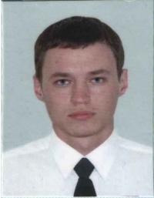

Experience:
Position | From / To | Vessel name | Vessel type | DWT | ME | BHP | Flag | Shipowner | Crewing
Ordinary Seaman | 03.07.2011-05.09.2011 | Ohakov | Dry Cargo | 998 |  | - | Ukr | Ukrrahflot | &mdash;
Ordinary Seaman | 20.08.2008-10.10.2009 | Zodiak | Fishing Vessel | 285 |  | - | Ukr | Afolina | &mdash;

Documents and further information:
Окончил ХМК (Херсонский Морской Коледж) в 2011 году по специальности судоводитель.

