Sergey Sharygin
Position applied for: 3rd Engineer  Date of birth: 11.05.1977 (age: 40)  Citizenship: Ukraine  Residence permit in Ukraine: Yes  Country of residence: Ukraine  City of residence: Kherson  Permanent address: koroluka,124  Contact Tel. No: +38 (055) 233-60-32 / +38 (059) 617-81-89  E-Mail: Sharygin1977@mail.ru  U.S. visa: No  E.U. visa: No  Ukrainian biometric international passport: Not specified  Date available from: 10.10.2014  English knowledge: Good  Minimum salary: 2000 $ per month | 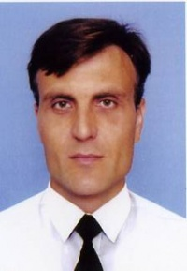

Experience:
Position | From / To | Vessel name | Vessel type | DWT | ME | BHP | Flag | Shipowner | Crewing
2nd Engineer | 27.11.2013-05.06.2014 | Amur 2532 | General Cargo | 3500 | Skoda | 1030 | Cambodia | Md shiping | Azimut
3rd Engineer | 04.02.0013-16.08.2013 | Amur 2514 | General Cargo | 3500 | Skoda | 1030 | Belize | Md shiping | Azimut
3rd Engineer | 28.08.2012-12.12.2012 | Erna | Dry Cargo | 3100 | Skl | 1240 | Cambodjia | Md Shiping | Azimut
Motorman 1st class | 25.01.2009-10.06.2009 | Dimitris P | Dry Cargo | 6800 | B@W | 3000 | S.Vinsent | Nideir maritime inc. | Aquariys
Motorman 1st class | 06.01.2008-22.06.2008 | Michail M | Dry Cargo | 6870 | B@W | 2950 | S.Vinsent | Nideir maritime inc. | Aquariys

Documents and further information:
+380506178189

