Kovalyov Kostyantyn
Position applied for: Master  Date of birth: 11.12.1978 (age: 38)  Citizenship: Ukraine  Residence permit in Ukraine: Yes  Country of residence: Ukraine  City of residence: Odessa  Contact Tel. No: +38 (097) 466-08-76  E-Mail: kostasmar@yandex.ru  U.S. visa: No  E.U. visa: No  Ukrainian biometric international passport: Not specified  Date available from: 24.07.2014  English knowledge: Excellent  Minimum salary: 12000 $ per month | 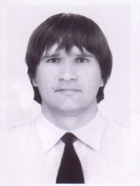

Experience:
Position | From / To | Vessel name | Vessel type | DWT | ME | BHP | Flag | Shipowner | Crewing
Master | 27.04.2014-27.06.2014 | Waha Mermaid | Anchor Handling Tug Supply | 1083 |  | 5100 | St Vincent |  | &mdash;

