Savruk Andrey Vitalievich
Position applied for: Motorman 2nd class  Date of birth: 06.12.2013 (age: 3)  Citizenship: Ukraine  Residence permit in Ukraine: No  Country of residence: Ukraine  City of residence: Odessa  Permanent address: Odessa  Contact Tel. No: +38 (096) 713-15-74  E-Mail: savruk2013@yandex.ua  U.S. visa: No  E.U. visa: No  Ukrainian biometric international passport: Not specified  Date available from: 01.11.2013  English knowledge: Moderate  Minimum salary: 300 $ per month | 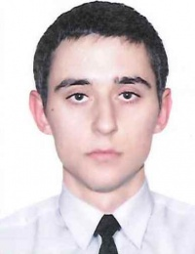

Experience:
Position | From / To | Vessel name | Vessel type | DWT | ME | BHP | Flag | Shipowner | Crewing
Motorman 2nd class | 20.09.2012-20.11.2012 | Hadzibey | Passenger Ship | 657 | Zulzer | 1140 | Ukrraine | "OMPT" barbout charter sc. chp. "Solex" | Pastera

