Грицкевич Владимир Иванович
Position applied for: Boatswain  Date of birth: 28.09.1950 (age: 67)  Citizenship: Ukraine  Residence permit in Ukraine: No  Country of residence: Ukraine  City of residence: Mariupol  Contact Tel. No: +38 (068) 670-31-33  E-Mail: Dashagrickevich@mail.ru  U.S. visa: No  E.U. visa: No  Ukrainian biometric international passport: Not specified  Date available from: 13.08.2009  English knowledge: Moderate  Minimum salary: 1500 $ per month | 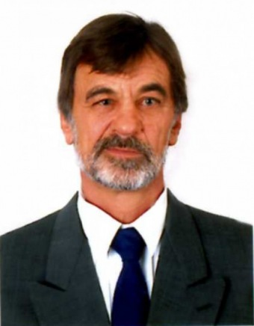

Experience:
Position | From / To | Vessel name | Vessel type | DWT | ME | BHP | Flag | Shipowner | Crewing
Boatswain | 08.05.2008-18.03.2009 | AFEA | Bulk Carrier |  |  | - | CYPRUS | COSMOS | &mdash;
Boatswain | 18.09.2007-16.01.2008 | AFEA | Bulk Carrier |  |  | - | CYPRUS | COSMOS | &mdash;
Boatswain | 20.06.2006-13.04.2007 | JIMAKOS T |  |  |  | - | ST. VINCENT | TRUST SHIPPING ENTERPRICE | &mdash;
Boatswain | 21.09.2004-28.09.2005 | JIMAKOS T |  |  |  | - | ST. VINCENT | TRUST SHIPPING ENTERPRICE | &mdash;
Boatswain | 25.06.2003-04.04.2004 | JIMAKOS T |  |  |  | - | ST. VINCENT | TRUST SHIPPING ENTERPRICE | &mdash;

Documents and further information:
EDUCATION
ROSTOV SECONDARY MARINE SCHOOL RUSSIA 1982 1985 TECHNICIAN NAVIGATOR

CERTIFICATES AND OTHER DOCUMENTS
Certificate of Competency 02381/2003/08 25.06.03 ODESSA
Endorsement 02381/2003/08 20.03.08 24.02.11 MARIUPOL
Survival craft 10818-AS 08.02.08 08.02.13 MARIUPOL
Advanced fire fighting 10465-AS 06.02.08 06.02.13 MARIUPOL
Hazardous Cargoes 10456-AS 14.02.08 14.02.13 MARIUPOL
Basic Training 05071 MA 24.02.06 24.02.11 MARIUPOL

PASSPORTS
SEAMAN’S IDENTIFICATION CARD AB 263135 10.06.03 23.01.11 ODESSA
PASSPORT AM 095725 17.04.00 17.04.10 MARIUPOL

