Kim Eduard
Position applied for: Motorman 2nd class  Date of birth: 20.05.1986 (age: 31)  Citizenship: Ukraine  Residence permit in Ukraine: No  Country of residence: Ukraine  City of residence: Kherson  Permanent address: 49 HGD Street 18/2-84  Contact Tel. No: +38 (099) 906-69-67  E-Mail: edz1es@yandex.ru  U.S. visa: No  E.U. visa: No  Ukrainian biometric international passport: Not specified  Date available from: 03.04.2014  English knowledge: Good  Minimum salary: 1000-1300 $ per month | 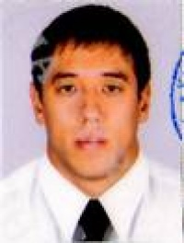

Experience:
Position | From / To | Vessel name | Vessel type | DWT | ME | BHP | Flag | Shipowner | Crewing
Motorman-Oiler | 20.06.2013-08.01.2014 | Roubini K | Bulk Carrier | 16600 | PIELSTICK 8PC2-5 | 5300 | Malta | Pilot shipping Thessaloniki/Greece | Murena
Motorman-Oiler | 17.10.2012-31.03.2013 | Nikolay Meshkov | Dry Cargo | 4947 | G-60 | 2x662 | Belize | Saluta shipping | Sail trade
Motorman-Oiler | 20.12.2011-13.06.2012 | Aleksandr Lebed | Dry Cargo | 4975 | Russian diesel G-70 2x1200 | 2x1200 | Belize | Saluta shipping | Sail trade

