Shekhovtsov Andriy
Position applied for: 3rd Engineer  Date of birth: 01.08.1985 (age: 32)  Citizenship: Ukraine  Residence permit in Ukraine: No  Country of residence: Ukraine  City of residence: Yalta  Contact Tel. No: +38 (063) 785-99-19 / +7 (865) 433-60-92  E-Mail: shahhh@mail.ua  U.S. visa: No  E.U. visa: No  Ukrainian biometric international passport: Not specified  Date available from: 15.01.2013  English knowledge: Good  Minimum salary: 2500 $ per month | 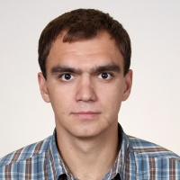

Experience:
Position | From / To | Vessel name | Vessel type | DWT | ME | BHP | Flag | Shipowner | Crewing
3rd Engineer | 18.08.2010-05.03.2011 | Tavriya | Dry Cargo | 3000 | 6NVD48AU | 1300 | Ukraine | Yalta sea trade port | &mdash;
3rd Engineer | 20.05.2009-14.03.2010 | Ivan Lesovikov | Dry Cargo | 3000 | 6NVD48AU | 1300 | Ukraine | Yalta sea trade port | &mdash;
3rd Engineer | 10.12.2007-13.11.2008 | Tavriya | Dry Cargo | 3000 | 6NVD48AU | 1300 | UKRAINE | Yalta sea trade port | &mdash;

