Rutenko Igor Volodymyrovych
Position applied for: 2nd Engineer  Date of birth: 23.05.1961 (age: 56)  Citizenship: Ukraine  Residence permit in Ukraine: No  Country of residence: Ukraine  City of residence: Mariupol  Permanent address: prospect Lenina 71/41 apt.37  Contact Tel. No: +38 (050) 701-77-83 / +38 (062) 933-33-53  E-Mail: igor-rutenko@mail.ru  U.S. visa: No  E.U. visa: No  Ukrainian biometric international passport: Not specified  Date available from: 20.11.2013  English knowledge: Good  Minimum salary: 6000 $ per month | 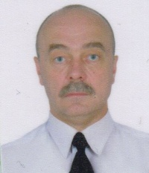

Experience:
Position | From / To | Vessel name | Vessel type | DWT | ME | BHP | Flag | Shipowner | Crewing
2nd Engineer | 03.02.2013-15.08.2013 | BLUE SAND | Bulk Carrier | 25.537 MT | SLZR 6 RTA48T | 10200 | PANAMA | BLUE SAND MARITIME CORP. | Shokk Marine agency

