Qartvelishvili Ruslan
Position applied for: Able Seaman  Additional position applied for: Ordinary Seaman  Date of birth: 25.02.1991 (age: 26)  Citizenship: Georgia  Residence permit in Ukraine: No  Country of residence: Georgia  City of residence: Batumi  Permanent address: batumi  Contact Tel. No: +995 (595) 002-367 / +995 (595) 002-367  E-Mail: ruslani6466@mail.ru  Skype: ruslani6466  U.S. visa: No  E.U. visa: No  Ukrainian biometric international passport: No  Date available from: 09.11.2017  English knowledge: Moderate  Minimum salary: 1100 $ per month | 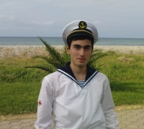

Experience:
Position | From / To | Vessel name | Vessel type | DWT | ME | BHP | Flag | Shipowner | Crewing
Deck Cadet | 03.12.2016-26.06.2017 | AYLISH | Dry Cargo | 5372 |  | 3815 | MALTA | AYLISH SHIPPONG LIMITED | &mdash;

