Deynega Aleksey
Position applied for: Motorman 1st class  Date of birth: 20.03.1984 (age: 33)  Citizenship: Ukraine  Residence permit in Ukraine: No  Country of residence: Ukraine  City of residence: Chernomorskoye  Contact Tel. No: +38 (050) 104-95-76  E-Mail: deynega84@mail.ru  U.S. visa: No  E.U. visa: No  Ukrainian biometric international passport: Not specified  Date available from: 16.10.2011  English knowledge: Poor  Minimum salary: 1500 $ per month | 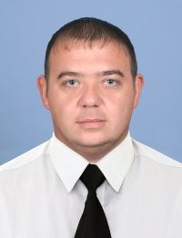

Experience:
Position | From / To | Vessel name | Vessel type | DWT | ME | BHP | Flag | Shipowner | Crewing
Motorman 1st class | 16.10.2012-16.06.2013 | Naftogaz-68 | Anchor Handling Tug Supply | 2723 | Zulzer | 2*2650 | Ukraine |  | state joint stoc company "Chernomornefte
Motorman 1st class | 26.12.2011-14.03.2012 | Majestic | Anchor Handling Tug Supply | 2921 | MAN | 2*4500 | Kingstown |  | state joint stoc company "Chernomornefte

