Nakonechniy Volodymyr
Position applied for: Motorman 1st class  Date of birth: 20.05.1972 (age: 45)  Citizenship: Ukraine  Residence permit in Ukraine: No  Country of residence: Ukraine  City of residence: Kherson  Contact Tel. No: +38 (066) 200-88-27  E-Mail: nakko72@gmail.com  U.S. visa: No  E.U. visa: No  Ukrainian biometric international passport: Not specified  Date available from: 26.06.2013  English knowledge: Poor  Minimum salary: 800 $ per month | 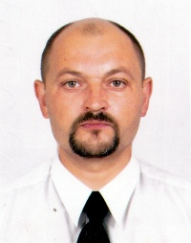

Experience:
Position | From / To | Vessel name | Vessel type | DWT | ME | BHP | Flag | Shipowner | Crewing
Oiler | 20.04.2012-20.11.2012 | Sea Cheetah | Anchor Handling Tug Supply | 2301 | Wartsila | 5520 | Cyprus | DSS | Direct employment
Oiler | 02.11.2011-12.04.2012 | Sea Cheetah | Anchor Handling Tug Supply | 5520 | Wartsila | 5520 | Cyprus | DSS | Direct employment
Wiper | 23.05.2011-23.07.2011 | BT-0645 | Tug Boat | 100 | NVD | - | Ukraine |  | &mdash;

Documents and further information:
All docs acc. to SCTW.

