Романовский Денис Валерьевич
Position applied for: Deck Cadet  Date of birth: 10.01.1982 (age: 35)  Citizenship: Ukraine  Residence permit in Ukraine: No  Country of residence: Ukraine  City of residence: Mykolayiv  Permanent address: Славянская 47  Contact Tel. No: +38 (068) 254-79-86 / +38 (097) 271-11-55  E-Mail: romanovskiyden@mail.ru  U.S. visa: No  E.U. visa: No  Ukrainian biometric international passport: Not specified  Date available from: 03.09.2009  English knowledge: Poor  Minimum salary: 650 $ per month | 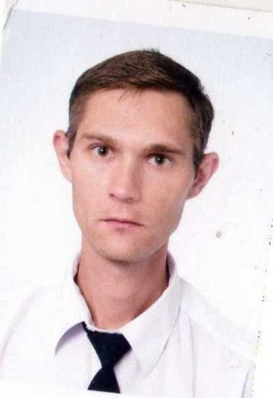

Experience:
Position | From / To | Vessel name | Vessel type | DWT | ME | BHP | Flag | Shipowner | Crewing
Ordinary Seaman | 23.03.2009-30.06.2009 | Принцесса Днепра | Passenger Ship |  |  | - |  |  | &mdash;
Deck Cadet | 15.12.2008-07.03.2009 | Аджигол | Tug Boat |  |  | - |  |  | &mdash;

