Дорошенко Николай Кузьмич
Position applied for: Master  Date of birth: 03.01.1945 (age: 72)  Citizenship: Ukraine  Residence permit in Ukraine: No  Country of residence: Ukraine  City of residence: Odessa  Permanent address: Люстдорфская дорога 142/2  E-Mail: pontform_dnk@mail.ru  U.S. visa: No  E.U. visa: No  Ukrainian biometric international passport: Not specified  Date available from: 01.06.2009  English knowledge: Excellent  Minimum salary: 5000 - 6000 $ per month | 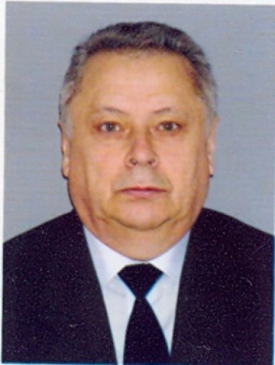

Experience:
Position | From / To | Vessel name | Vessel type | DWT | ME | BHP | Flag | Shipowner | Crewing
Master | 28.01.2008-10.10.2008 | EELEFTHERIA D | Bulk Carrier | 68800 | Sulzer | 1600 | Panama | Standard Shipping, USA | IS Marine Services, Odessa
Master | 12.07.2006-12.03.2007 | Suerte | Bulk Carrier | 19800 | B&W | 9000 | Malta | Mariteam Services Inc., Gr | Panigo Enterprises, Keiv
Master | 01.09.2003-28.07.2005 | Perekopsky | Dredger | 6800 | Sulzer | 4000/2 | Ukraine | ЧеразМорпуть. Одесса | ЧеразМорпуть
Master | 29.10.2005-15.06.2005 | Black Rose | Bulk Carrier | 38950 | B&W | 12000 | Ulaan Baatar | Pacmar Shipping Inc., Singapore | Panigo Enterprises, Keiv

