Zubkov Alexandr
Position applied for: 2nd Officer  Date of birth: 24.03.1992 (age: 25)  Citizenship: Ukraine  Residence permit in Ukraine: No  Country of residence: Ukraine  City of residence: Kherson  Contact Tel. No: +38 (055) 251-37-47 / +38 (099) 934-14-88  E-Mail: qdalawar@gmail.com  U.S. visa: No  E.U. visa: No  Ukrainian biometric international passport: Not specified  Date available from: 11.03.2014  English knowledge: Good  Minimum salary: 1300 $ per month | 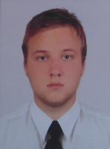

Experience:
Position | From / To | Vessel name | Vessel type | DWT | ME | BHP | Flag | Shipowner | Crewing
2nd Officer | 29.12.2012-06.06.2013 | Alvadi - 2 | General Cargo | 3134 |  | - | Moldova | Astra Marine Shipping | Sea Star 1
Ordinary Seaman | 07.09.2011-28.01.2012 | Alena | General Cargo | 6059 |  | - | Malta | Alena Maritime Ltd | Rio Maritime

